Monitoring tools for OpenESB.
Paul Perez Pymma consulting : 19 Dec. 10

Introduction
The objective of this document is some detail on how we can architecture a performing and powerful monitoring tool for OpenESB. The document is a very draft that must be reviewed completed by users, architects and developers.

Monitoring features
Again I list here a very first list of feature
- Activities from component SE and BC, NMR and JBI Core
  - Message number
  - Message content
  - Response time
  - Success and fault number
- BPEL activity
  - BPEL instance number
  - BPEL global response time
  - BPEL response time per activity
  - State of the process per instance (where the process is)
- Non-functional features
  - Support clustering and multiple instances
  - Does not impact regular OpenESB performance
  - Compatible with Enterprise Monitoring tools
  - Can be used in standalone mode (console in graphical mode).
  - New plugin could be developed by tiers teams

Architecture
The architecture I propose for the project is simple and summarise in the picture below:
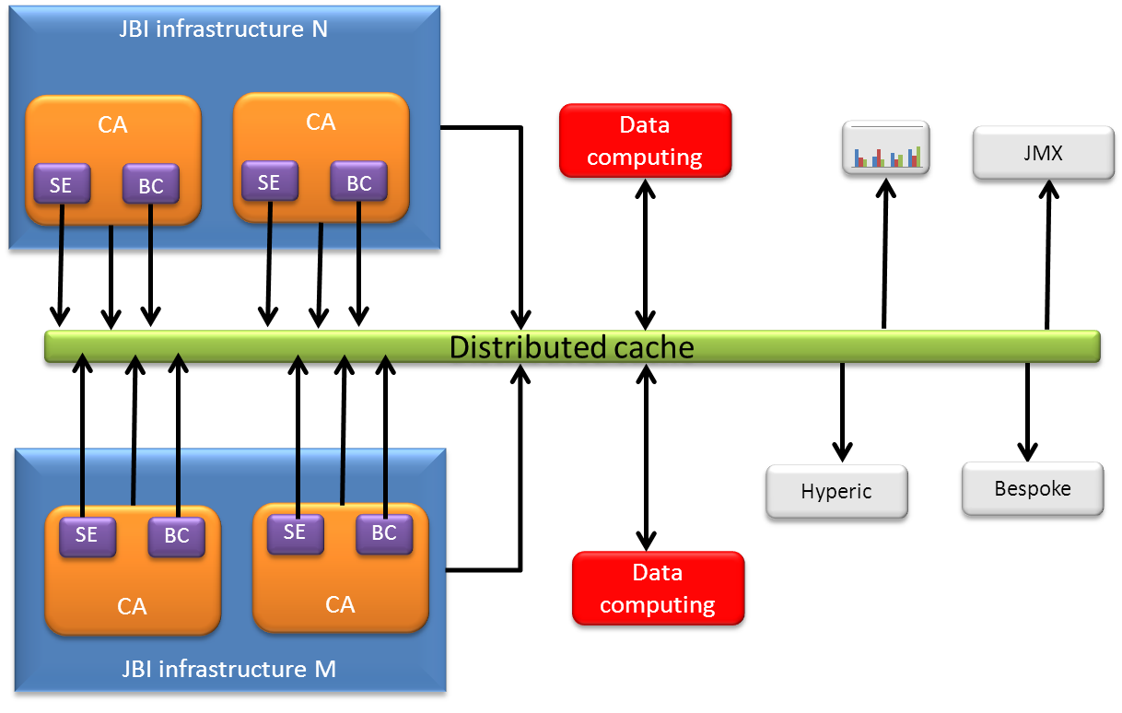

Distributed cache
The earth of the architecture is a distributed cache. In this document, I will not explain in detail the principles of this type of cache, but the main idea is that a cache user put a data in the cache and it is available for the other users of the cache. There are lot of cache on the market. I advise to use Hazelcast (www.hazelcast.com ) which is open source, supported on demand, fully written in Java, powerful and easy to use.

JBI Infrastructure
During the runtime, every component in the JBI infrastructure (SE, BC, NRM…) puts raw and simple data in the distributed cache. Simple date means just simple measures, like I receive a message at + time, I invoke a component at +time, the message at receive at +time is + message…
No statistics or sum or group by are computed at this level.

Data computing
Data computing are Java classes design to process raw data provided by JBI component in order to get more sophisticated data. EX: Statistics, state of a process, SLA measures.. Hazelcast allows a distributed computing through Task, Future and Executor. Data computing provides formatted data for monitoring tools.

Monitoring tools connector (in white)
The connectors are the links between the distributed cache and the monitoring tools. Through them the distributed cache becomes a datasource. Ex: A JasperReport connector picks up the data from the cache and presents them as a Java datasource to JasperReport.
Many connectors can be defined.

Pro and Con of the architecture

In that configuration, using a distributed cache is not straightforward and introduces a complexity in the monitoring tool for OpenESB. However on the other side, a distributed cache solves many issues:
- Avoid a development of a distributed architecture when clusters or multi instances are running at the same time.
- Decorrelates Data generation, data processing and connectors
- Does not introduce latency or single point of failure in the system.

What is your feedback
This is a very first document written to give you a first idea of the architecture we want to develop for the OpenESB monitoring tools. Feel free to send your comment you remark or your alternative solution. We just start the project. Everything is possible.
I would very please to red you
Paul perez
www.pymma.com

